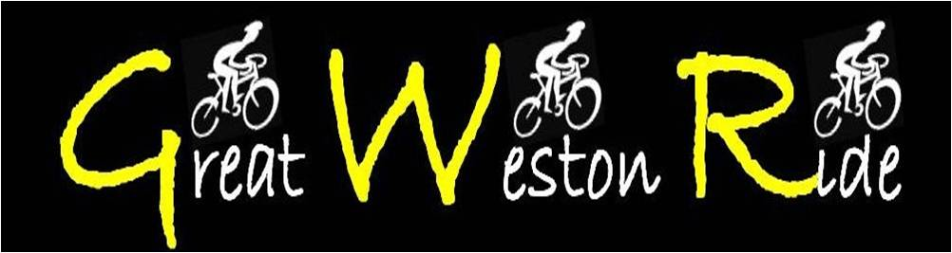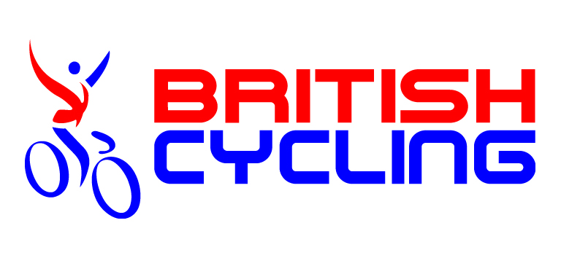

2022 EVENT ENTRY FORM

To the Organiser (please complete in CAPITAL LETTERS):

Event name: | GREAT WESTON  RIDE | Event date: | 17.07.22 | Ride name/  distance: | 57 miles
Title: |  | Date of Birth:
First name: |  | Surname:
Address:
Town: |  | County:
Postcode: |  | Mobile no:
Email:
Emergency  contact name: |  | Emergency  contact no:
Entry fee:  (delete as appropriate) |  | £33 – Adult  £16.50 – Under 16  £16 – Transport to Bristol (PM) or (AM)
I enclose event entry fee of:  (cheque made payable to GREAT WESTON RIDE) |  |  | £
"I declare that the information on this form is complete and correct. I agree to abide by the British Cycling Regulations for non-competitive cycling events, and understand and agree that I participate in this event entirely at my own risk, that I must rely on my own ability in dealing with all hazards, and that I must ride in a manner which is safe to myself and others. I am aware that when riding on a public highway the function of marshals is only to indicate direction and that I must decide whether the movement is safe. I agree that no liability whatsoever shall attach to the promoter, promoting club/Organisation, event sponsor, British Cycling or any event official or member of British Cycling or member of the promoting club/organisation in respect of any injury, loss or damage suffered by me in or by reason of the event, however caused. I have read and agree to abide by the above declarations and the event's Conditions of Entry”.
Signed: |  |  | Date:
ENTRIES WITHOUT CORRECT FEE OR DETAILS WILL NOT BE ACCEPTED

Completed entry form(s) & payment should be sent to:
Great Weston Ride, 15 Lake Road, Henleaze, Bristol BS10 5HG

